# 

Audit Summary Report

Test Inc.  
www.google.com

**Provided by Allyant**

**8/29/2024**

# 

# **Introduction & Approach**

Test Inc. website was professionally audited by members of Allyant’s accessibility audit team consisting of both sighted and visually impaired individuals. This summary report serves as a high-level review of the website accessibility audit. We highlight specific issues identified on the website as experienced by a screen reader user.

Allyant focused on identifying and documenting all issues that could potentially impact users with blindness, visual impairment, motor impairment, color blindness, hearing impairment, or deafness. This includes issues common for keyboard-only users; visual features affecting users who rely on magnification and high-contrast; audio-only features affecting those with hearing loss; and any items possibly posing difficulty for users with some form of cognitive impairment.

The in-­depth review of Test Inc.’s site using screen readers was executed on desktop computers with Job Access With Speech 2023 (JAWS) and NonVisual Desktop Access 2023.1 (NVDA).

The issues and solutions identified are indicated individually in the Allyant HUB project. For each issue, this includes an evaluation of the category/type of issue and its recommended priority related to the impact on user accessibility.

# **Scope of Work**

Allyant audited the representative set of undefined outlined in the Statement of Work for this project. For each identified issue, we include a solution or direction we believe is both best for the situation and easiest or most cost-effective for your developers to implement. The issues identified in the set of views audited *must* be applied globally to your digital property. We encourage Test Inc. to apply the recommended fixes as soon as possible, particularly if the Website is updated often.

# 

# **Narrative of Key Findings**

## **Overview**

In our review of Test Inc.’s website, we found 21 issues identified across the representative set of 21 views.

To further help you focus your remediation, we have identified the following top areas of concern. These were chosen either due to the severity level of the accessibility issue or the volume of instances we encountered during the audit.

1. **Category 1: Navigation and Focus Management**

* **Issue 1:** Navigation menus that open on hover must be able to be triggered by keyboard and screen reader users. [Link](https://hub.accessible360.com/issues/575014/edit) (Example issue #1 under Category 1)
* **Issue 2:** Closing this modal dialog does not return the user to the element that opened it. [Link](https://hub.accessible360.com/issues/575026/edit) (Example issue #2 under Category 1)

1. **Category 2: ARIA Attributes and Labels**

* **Issue 3:** This modal dialog is missing necessary ARIA attributes. [Link](https://hub.accessible360.com/issues/575028/edit) (Example issue #1 under Category 2)
* **Issue 4:** The modal dialog container is not labeled. [Link](https://hub.accessible360.com/issues/575025/edit) (Example issue #2 under Category 2)

1. **undefined**

* **Issue 5:** This color combination does not meet the minimum color contrast required by the WCAG. The combination of blue (#26b1eb) and white (#FFFFFF) only has a contrast ratio of #2.45:1. [Link](https://hub.accessible360.com/issues/575917/edit) (Example issue #1 under Category 3)
* **Issue 6:** Focus indicators must meet the minimum color contrast required by the WCAG. The combination of blue (#9EDAFA) and white (#FFFFFF) only has a contrast ratio of 1.51:1. [Link](https://hub.accessible360.com/issues/577008/edit) (Example issue #2 under Category 3)

### Full List of Project Issues

A comprehensive list of all issues can be found in the Allyant HUB undefined

## **How to Approach Remediation**

In addition to reviewing the top issues found, we recommend that your developer(s) review all issues in the audit and find the solution that is most appropriate to your website There are a few different approaches that can be taken to prioritize the resolution of issues; below are some examples of such.

### By Components

Grouping by component allows teams to focus on larger pieces of functionality and remediate issues that have logical relationships to one another. As an example, if a carousel has accessibility issues, fixing the carousel as a whole is more efficient than fixing each issue separately.

To view issues by component, there is a components report in the Allyant HUB. Simply navigate to the “Quick Links” drop down and select “All Project Components”, shown below.

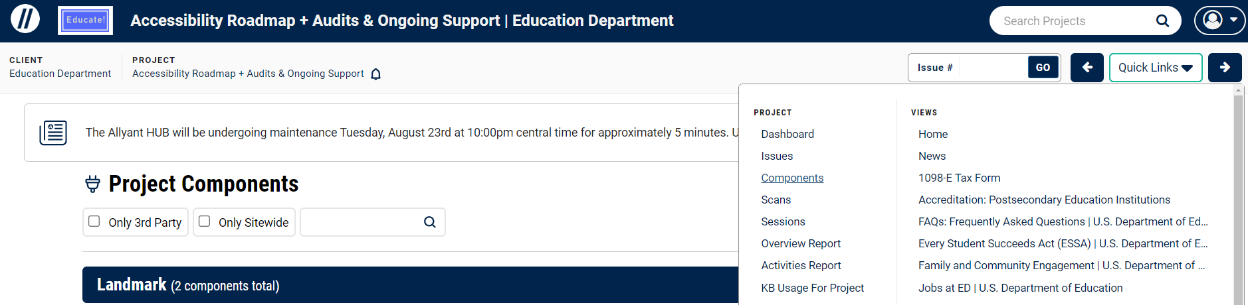

### Sitewide Issues

Filtering issues by “site wide only” allows you to see issues that are present on the majority of the views. Oftentimes the development team can resolve these once and the update will be rolled out globally throughout the digital property.

To view sitewide issues, leverage the “filter issues” drop down in the Allyant HUB “Project Issue Reports” as shown below.

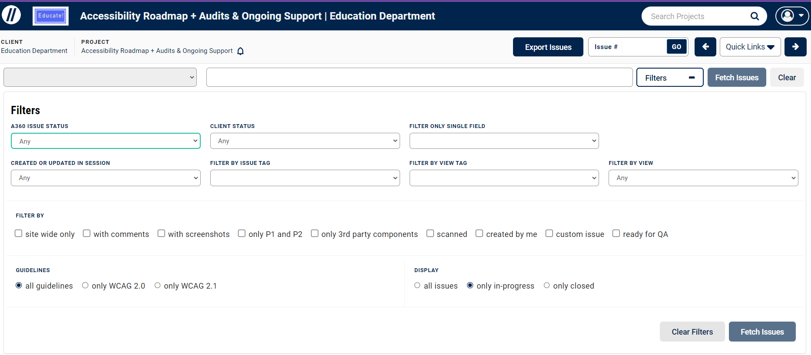

### Priority

Items marked as Critical/Priority 1 are almost always blockers preventing access to information on the site. Fixing these issues will greatly improve the accessibility of your digital property. The team could then move on to Serious/Priority 2 issues, and finally, Warning/Priority 3 issues.

To view issues by priority, simply leverage the “Group Issues By” drop down and select “Priority” in the Allyant HUB “Project Issue Reports” as shown below.

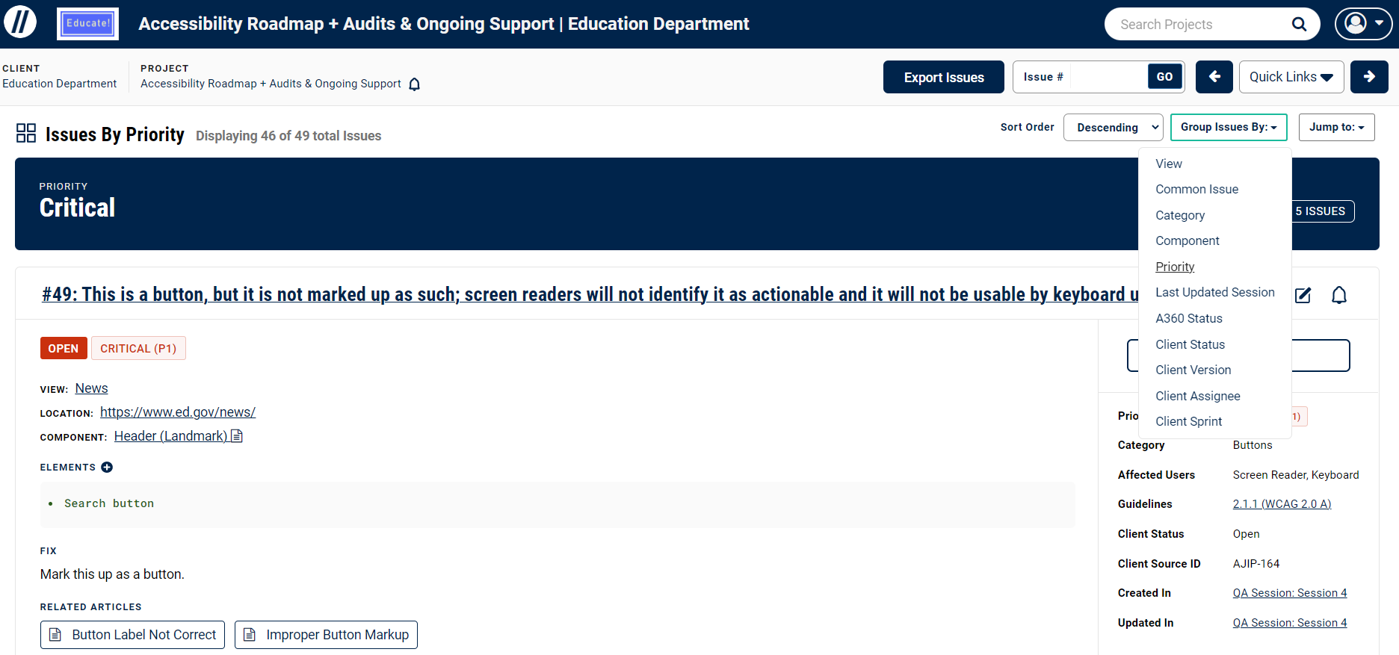

## **Important Notes:**

* While we endeavor to identify every accessibility issue in our initial audit, it is not uncommon for new issues to be uncovered during subsequent reviews of the digital property. See the ["Why new issues appear following an audit" article in the Allyant HUB Knowledge Base](https://hub.accessible360.com/kb/articles/1096) for more information and to find a calculator which can help you estimate the number of additional issues you should expect.
* Do keep in mind that all issues which are fixed need to be fixed globally across the digital property, not only in the instances on specific views that we have documented.
* We test web projects using the latest versions of the JAWS and NVDA screen readers, as these are by far the most widely used screen readers. We highly recommend all teams review our Knowledge Base article [here](https://hub.accessible360.com/kb/articles/189), which provides additional detail.
* We test mobile projects using the current versions of TalkBack (Android) and VoiceOver (iOS).
* We have collected some tools that may be useful during your remediation and testing process. Please reference our [Links & Resources Knowledge Base article](https://hub.accessible360.com/kb/articles/251) as well as our [Color Contrast Tools Knowledge Base article](https://hub.accessible360.com/kb/articles/40). Finally, our [Accessibility Badge and Statement article](https://hub.accessible360.com/kb/articles/362) can also be referenced if you haven’t posted one to your digital property yet.

### undefined

### undefined

# **Next Steps**

Please review the information provided and work with your Customer Success Manager to define a remediation and QA Testing project plan. This will ensure all parties are working toward the same deadline for conformance. Allyant will gladly provide support as needed to resolve these outstanding issues.